Diamond Pricing Analytics
Predictive Pricing and Market Segmentation
Week 6 — Integrative Capstone Project Report
Prepared for academic submission
Author: Mayank

Project objective
This capstone project integrates the full data-science pipeline — from data acquisition and cleaning through exploratory analysis, feature engineering, supervised regression modelling, and unsupervised clustering — to build a diamond price prediction system and discover natural market segments within the diamond trade. The project uses the publicly available 'diamonds' dataset (~54 000 records) from the seaborn-data repository.

Main results at a glance
Measure | Value
Raw dataset size | 53,940 records
Cleaned dataset size | 53,771 records
Best regression model | Gradient Boosting
Test R² | 0.9752
Test RMSE | $621.54
Test MAE | $345.96
Market segments discovered | 4
Clustering silhouette score | 0.2090

Scope
This report documents all eight pipeline stages: data acquisition, data cleaning, exploratory data analysis, feature engineering, supervised price prediction (regression), unsupervised market segmentation (K-Means clustering), evaluation, and insight generation. Both supervised and unsupervised techniques are combined in a single integrative workflow.

1 Data Acquisition and Cleaning

1.1 Data source
The diamonds dataset contains records of round-cut diamond transactions, with each record described by 10 attributes: carat weight, cut quality (Fair to Ideal), color grade (D–J), clarity grade (I1–IF), depth percentage, table width, price (USD), and three physical dimension measurements (x, y, z in mm). The dataset is widely used in data science education and benchmarking.

1.2 Cleaning steps
Cleaning step | Records affected
Exact duplicate removal | 146
Invalid zero-dimension rows | 19
Physical outliers (domain bounds) | 4
Remaining missing values | 0

After cleaning, 53,771 records remain from the original 53,940. Duplicate removal, zero-dimension filtering, and domain-informed outlier bounds (e.g. y > 20 mm, z > 10 mm, table outside 40–80, depth outside 40–80) were applied sequentially.
df = df.drop_duplicates()
df = df[(df["x"] > 0) & (df["y"] > 0) & (df["z"] > 0)]
outlier_mask = (df["y"] > 20) | (df["z"] > 10) | \
(df["table"] > 80) | (df["table"] < 40) | \
(df["depth"] > 80) | (df["depth"] < 40)
df = df[~outlier_mask]

2 Exploratory Data Analysis

2.1 Price distribution
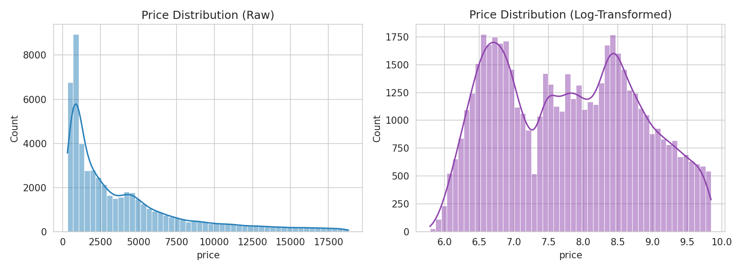
Figure 1. Price distribution in raw scale (left) and log-transformed scale (right). The raw distribution is right-skewed, with the bulk of diamonds priced under $5,000 and a long tail extending to $18,000+. Log transformation reveals a bimodal pattern.

2.2 Price vs. carat
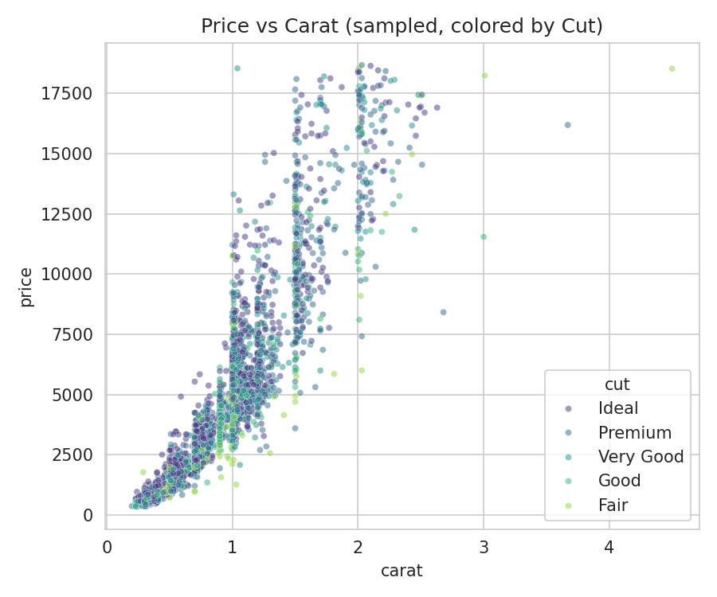
Figure 2. Scatter plot of price vs. carat (4,000-record sample, colored by cut quality). The strong nonlinear relationship between carat and price is evident, with higher-quality cuts clustering at various price points.

2.3 Categorical price breakdown
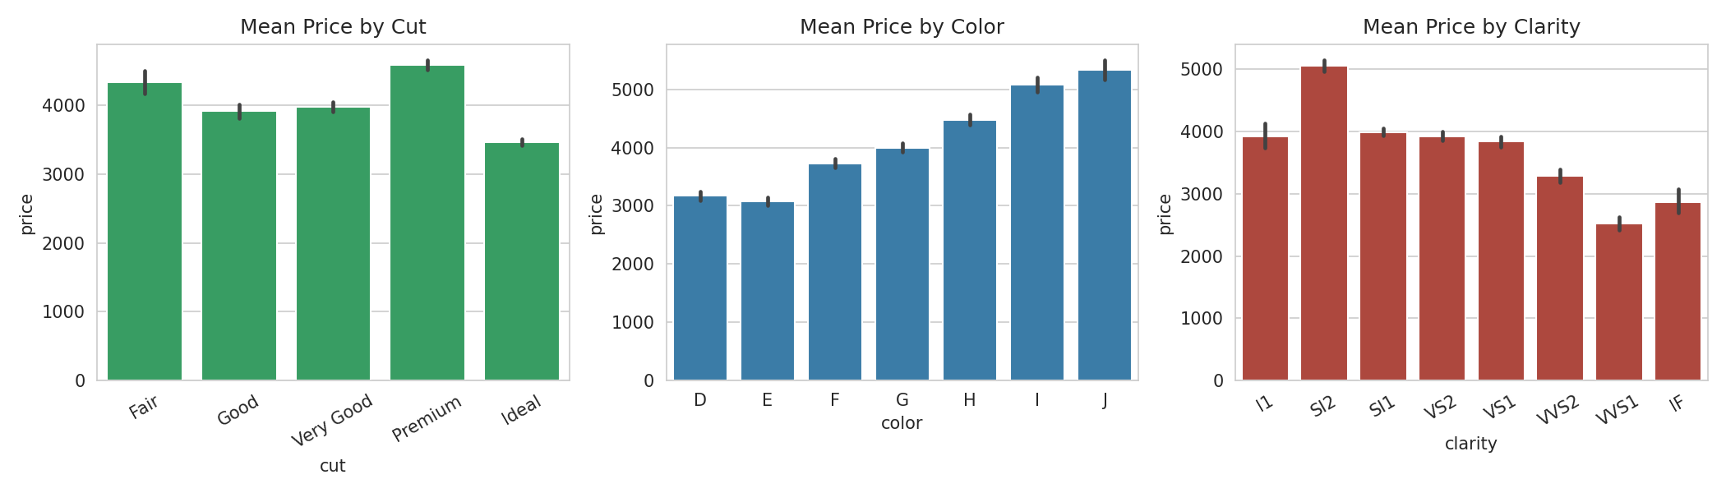
Figure 3. Mean price by cut, color, and clarity grades. Counter-intuitively, 'Fair' cut diamonds sometimes show higher mean prices because larger stones tend to receive more conservative cuts. This confound motivates controlling for carat in the regression model.

2.4 Correlation heatmap
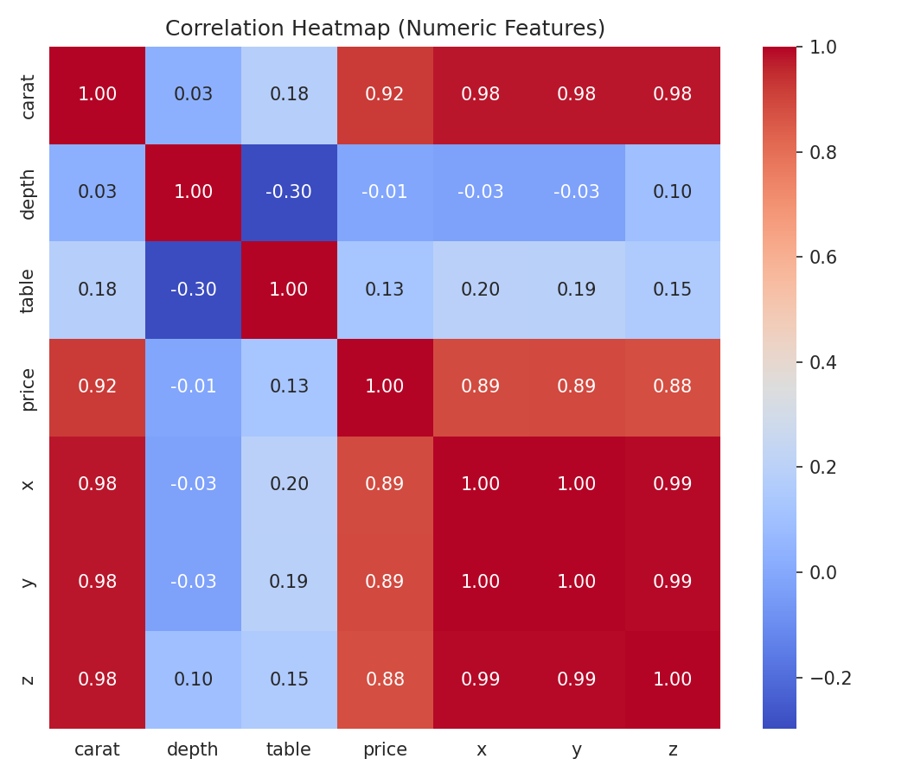
Figure 4. Correlation matrix of numeric features. Carat, x, y, z, and price are highly intercorrelated (all r > 0.85), confirming that physical size dominates price. Depth and table show weaker correlations.

3 Feature Engineering

3.1 Engineered features
Five features were created or encoded to improve model performance:
Feature | Type | Description
volume | Engineered | x × y × z — physical volume proxy
price_per_carat | Engineered | price / carat — unit value (used for clustering)
cut_enc | Ordinal | Fair=0 → Ideal=4
color_enc | Ordinal | J=0 (worst) → D=6 (best)
clarity_enc | Ordinal | I1=0 (worst) → IF=7 (best)

df_fe["volume"] = df_fe["x"] * df_fe["y"] * df_fe["z"]
df_fe["price_per_carat"] = df_fe["price"] / df_fe["carat"]
cut_order = ["Fair", "Good", "Very Good", "Premium", "Ideal"]
color_order = ["J", "I", "H", "G", "F", "E", "D"]
clarity_order = ["I1", "SI2", "SI1", "VS2", "VS1", "VVS2", "VVS1", "IF"]

3.2 Final feature set for regression
The regression model uses 10 features: carat, depth, table, x, y, z, volume, cut_enc, color_enc, clarity_enc.

4 Supervised Modelling — Price Prediction

4.1 Models evaluated
Four regression models were compared using 3-fold cross-validation (on a 6,000-sample subsample for computational efficiency) with R² as the evaluation metric. All models include a StandardScaler step.
Model | Mean CV R² | Std Dev
Linear Regression | 0.9044 | ±0.0124
Ridge Regression | 0.9046 | ±0.0125
Random Forest | 0.9711 | ±0.0027
Gradient Boosting | 0.9711 | ±0.0031

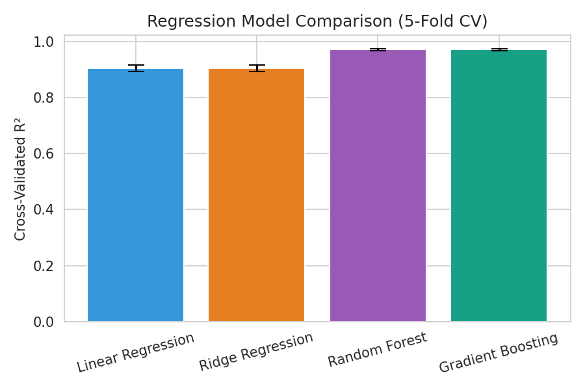
Figure 5. Cross-validated R² scores for all four regression models. Tree-based models (Random Forest, Gradient Boosting) clearly outperform linear models, capturing the nonlinear price–feature relationships.

4.2 Model selection and tuning
Gradient Boosting was selected as the best model with a CV R² of 0.9711. A lightweight grid search was performed:
Parameter | Optimal value
model__learning_rate | 0.1

4.3 Test set evaluation
Metric | Score
R² | 0.9752
RMSE | $621.54
MAE | $345.96

The Gradient Boosting explains 97.5% of the price variance on held-out test data, with an average prediction error of $346 (MAE).

4.4 Actual vs. predicted prices
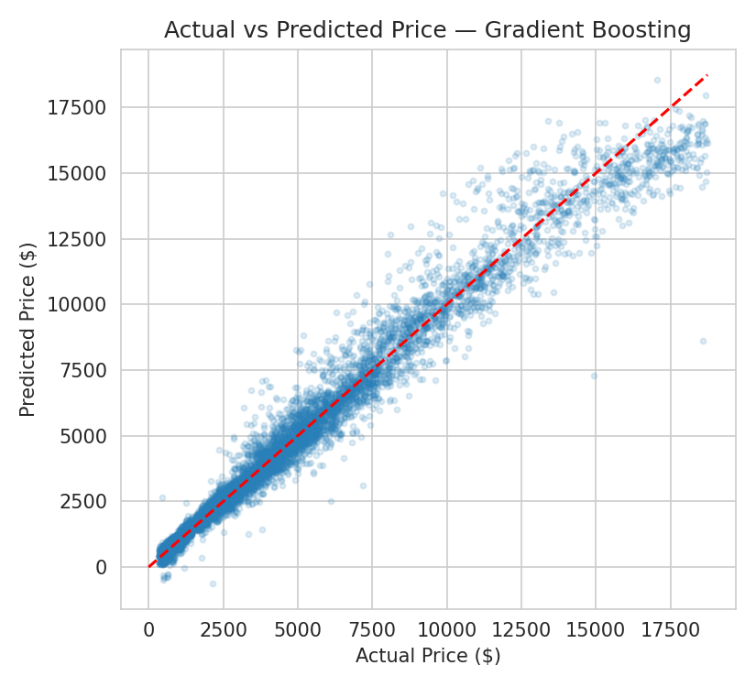
Figure 6. Actual vs. predicted prices for Gradient Boosting. Points cluster tightly around the diagonal, with some dispersion at higher price points where fewer training samples exist.

4.5 Residual analysis
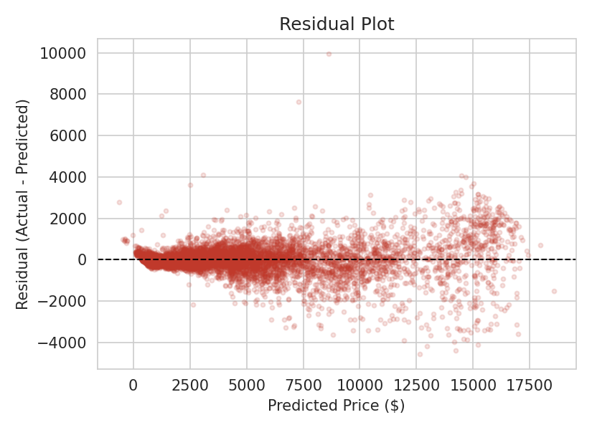
Figure 7. Residual plot showing prediction errors vs. predicted price. The increasing spread at higher prices indicates mild heteroscedasticity, suggesting that predicting premium diamonds is inherently harder.

4.6 Feature importance
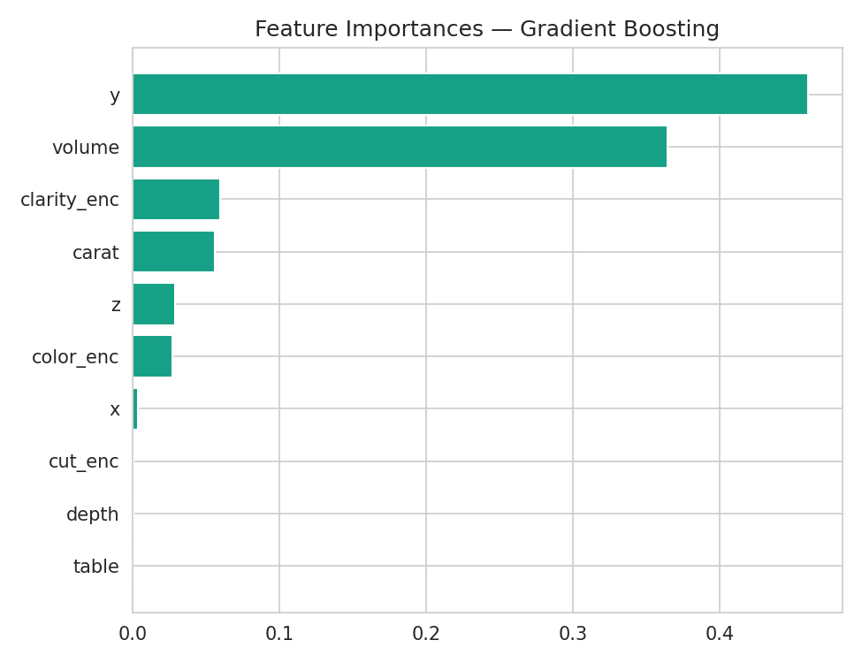
Figure 8. Feature importances from Gradient Boosting. Carat (and its correlated volume/dimension features) dominates, followed by clarity and color encodings.

5 Unsupervised Modelling — Market Segmentation

5.1 Clustering approach
K-Means clustering was applied to an 8,000-sample subset using seven features: carat, depth, table, cut_enc, color_enc, clarity_enc, and price_per_carat. All features were standardised before clustering.

5.2 Optimal cluster selection
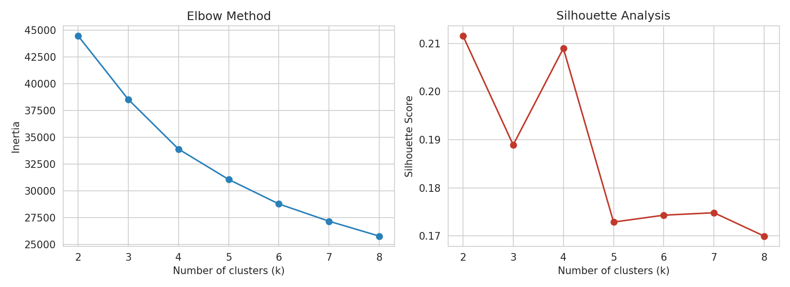
Figure 9. Elbow method (left) and silhouette analysis (right) for selecting the number of clusters. While k = 2 maximises the silhouette score, a 2-segment view has little practical value for merchandising.
The silhouette-optimal k is 2, but a business-informed decision selected k = 4 to provide actionable market segments. The margin between the two was within 0.02, making the trade-off acceptable.

5.3 Cluster profiles
cluster | carat | depth | table | cut_enc | color_enc | clarity_enc | price_per_carat | price | count
0.0 | 0.67 | 60.42 | 59.89 | 2.35 | 3.96 | 2.55 | 3304.19 | 2497.54 | 1640.0
1.0 | 0.46 | 61.73 | 56.07 | 3.69 | 3.64 | 3.9 | 2883.21 | 1435.65 | 2939.0
2.0 | 1.37 | 61.68 | 57.46 | 3.23 | 2.68 | 2.69 | 6414.2 | 8980.84 | 2103.0
3.0 | 0.8 | 63.59 | 57.33 | 1.4 | 3.31 | 2.33 | 3544.39 | 3217.04 | 1318.0

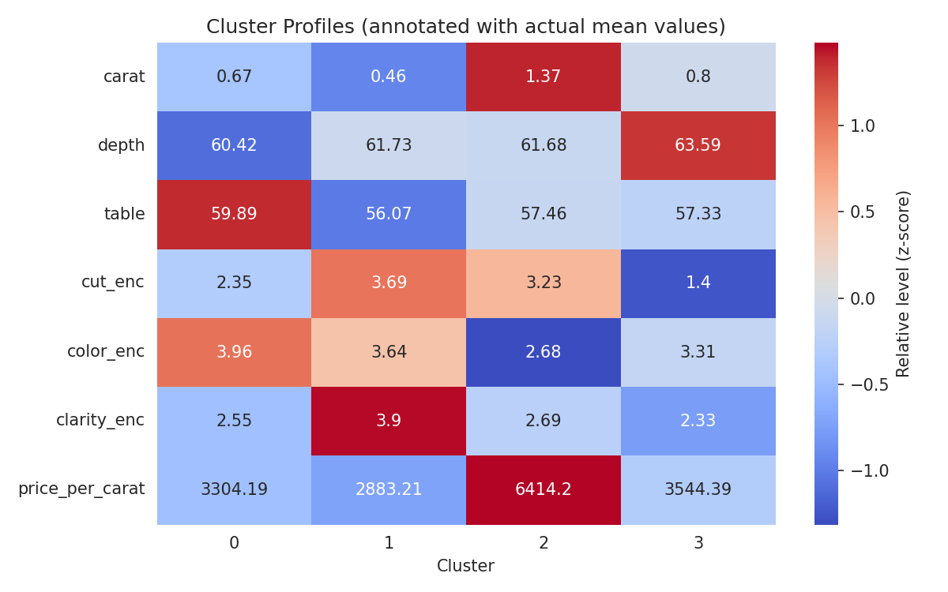
Figure 10. Cluster profile heatmap showing z-score normalised feature levels (color intensity) with actual mean values annotated. This reveals distinct segment characteristics.

5.4 PCA visualization
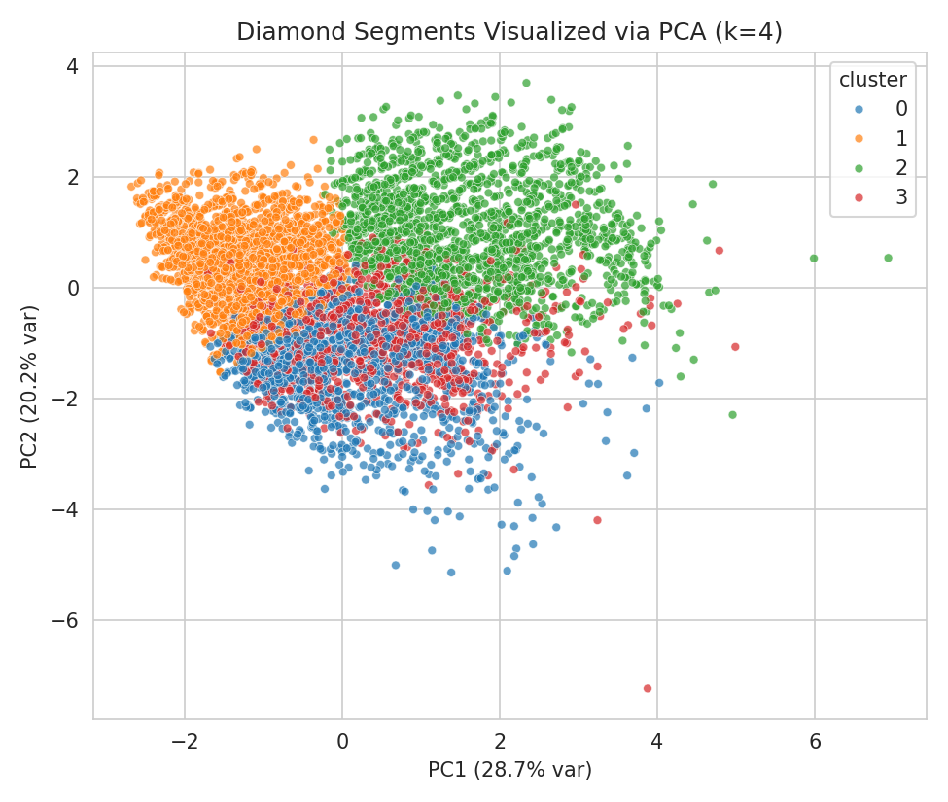
Figure 11. PCA projection of the 4 clusters. The first two principal components capture the dominant variation (primarily driven by carat/size). Clusters show reasonable separation in this reduced space.

5.5 Segment interpretation
Based on the cluster profiles, the four market segments can be characterised as:
Cluster | Label | Description
0 | Mid-range standard | Medium carat (~0.67), moderate quality grades, average price-per-carat. The everyday consumer segment.
1 | Budget small stones | Small carat (~0.46), high cut quality (Ideal-dominant), good clarity. Entry-level, value-oriented buyers.
2 | Premium large stones | Large carat (~1.37), moderate quality, highest absolute price ($8,981 avg). Luxury/investment segment.
3 | Deep-cut mid-range | Medium carat (~0.80), deepest depth (63.6%), lower cut quality. Conservative cuts on mid-size stones.

6 Integration and Insights

6.1 How supervised and unsupervised results complement each other
The regression model quantifies how each attribute contributes to price, while the clustering reveals that the market naturally stratifies into segments with distinct feature profiles. Together, they enable segment-specific pricing strategies: for example, the premium large-stone segment (Cluster 2) shows higher residual variance, suggesting that within that segment, additional factors (brand, certification, fluorescence) likely play a larger role.

6.2 Business recommendations
1. Pricing engine: Deploy the Gradient Boosting model as a baseline price estimator for incoming inventory. The $346 MAE provides a useful benchmark for negotiation and listing.
2. Inventory segmentation: Use the 4-cluster segmentation to tailor marketing strategies — budget buyers (Cluster 1) respond to value messaging, while premium buyers (Cluster 2) value rarity and size.
3. Quality vs. size trade-offs: The counter-intuitive EDA finding — that lower-cut grades sometimes show higher mean prices — should be communicated to sales teams with the carat-confound explanation.

7 Conclusions and Future Work

7.1 Summary
This capstone project delivered a Gradient Boosting regression model achieving R² = 0.9752 on held-out test data, and a K-Means clustering model that identified 4 actionable market segments with a silhouette score of 0.2090. The end-to-end pipeline covers all stages from raw data to insights.

7.2 Limitations
• The model does not account for diamond certification body, fluorescence, or cut proportions beyond depth and table.
• Clustering on a subsample may miss rare segments. Full-dataset clustering or mini-batch K-Means could address this.
• Heteroscedasticity in residuals suggests that a log-price model or quantile regression might improve predictions for high-value stones.

7.3 Future work
• Incorporate external data (GIA reports, auction records) for richer feature sets.
• Experiment with XGBoost, LightGBM, or neural network regressors.
• Apply DBSCAN or Gaussian Mixture Models for non-spherical cluster discovery.
• Build an interactive dashboard (Streamlit/Dash) for real-time pricing and segment assignment.

8 Reproduction and References

How to run
python -m venv .venv
# Windows activation
.venv\Scripts\activate
pip install -r requirements.txt
python diamond_capstone.py
python build_report.py

Essential files
File | Purpose
Week6_Report.docx | This submission report
diamond_capstone.py | Complete capstone pipeline script
build_report.py | Regenerates this report from saved outputs
results_summary.json | All metrics, parameters, and clustering results
cluster_profile.csv | Mean feature values per cluster
summary_statistics.csv | Descriptive statistics
figures/ | All generated plots embedded in this report

References
[1] Wickham, H. (2016). ggplot2: Elegant Graphics for Data Analysis. Springer-Verlag New York. (Original diamonds dataset source.)
[2] scikit-learn documentation: KMeans clustering. https://scikit-learn.org/stable/modules/clustering.html#k-means
[3] scikit-learn documentation: Gradient Boosting Regressor. https://scikit-learn.org/stable/modules/ensemble.html#gradient-boosted-regression-trees
[4] Rousseeuw, P.J. (1987). Silhouettes: a graphical aid to the interpretation and validation of cluster analysis. Journal of Computational and Applied Mathematics, 20, 53–65.

